Family life: Christian partnership and family
Theses and statements/Discussion paper
God created Adam and Eve….
This very early words of the bible shows us who we are.
We are created as people who are dependent on each other. We need each other like the air to breath. We need relationship and most of us need a special, holy relationship with one special man or woman, to be a couple.
God’s holy idea is that of being somebody who is separated with your parents only for one person in the world. He knows us best; he created us as men and women. Two pieces of a picture, which are connected with each other creates the picture how Gods wants us. He says: It is not good that man should be alone…
To be somebody special, the number one partner is especially important today. In business or at work, we are more and more only numbers. But as a married person you are your partner’s number one. Think about that; you are the most important human on earth for somebody. Somebody misses you, when you do not come back from work. Somebody knows you and loves you the way you are.
Jesus shows us this is a picture of God’s love for us. We are somebody special before God.
God is good. He knows what we need. He created us and created us with all aspects: with the abilities to think, to feel, to forgive, to trust, to have sexual feeling, to live in a special relationship with one person for our whole lives, to have the wish to reproduce, etc.
He gave us the deep desire to be somebody’s special one. And, he gave us the rules to live such a life, as a couple. These rules are successful. Not the western life style, not the philosophers; God alone knows how to live a long life being blessed. These rules are in the Bible.
Today, most of the Christians are no longer more interested in these rules. They are Christians, but this area of life is not under Gods control. We have as Christian couples more devotions as are none Christians. The devil is attacking the couples and families, the most important units in a society.
Women are often not women anymore and men also, are often not men anymore. People say they are independent, they are equal, most of the differences between them are unrealistic, but in truth there are no differences between men and women.
People mix up the value question of men and women in general with the functions in the society and their standing.
To be a mother is not a job for which payment would be made, but to be employed to work is a paying service. So is it more important to go to work than to stay at home as a mother?
People also mix up the traditional values often based on bible values, with the thoughts of equality, and that equality cannot be there, where God given positions are. That is true. We are not equal; we are one half of a picture. Each is different, each is only a half, and together we are the full picture. That is an example for Christians who like to have a partner, not for everybody. Whoever prefers to be single being is not looking for somebody. The persons are happy with themselves.
But back to single persons, who are looking for partners: God created us; He knows what we really need. But you have to make the right decisions. A partner is not falling from heaven and a blessed relationship or a blessed family life is something you have to work on.

Questions:
Here are some questions for you to think about as extracted from the bible verses to praxis or better from the praxis to the bible:
Why only one partner? Why look for a partner who has a lot in common with me? Why look for a partner early? Why a Christian partner/one confession (Charismatic and bible truth conservative?)? Why have children in early years (biology of the women…)? Why no sex before marriage? Why honesty? Why leave the parents and be independent from them? Why stay at home the first years as mother? Why the husband is the head of the family? Why love your wife like Jesus loves us? Why obey your husband as a wife? Why pray together? Why be trustworthy and not tell others the private things pertaining to your partner, not even your best friend? Why speak with each other and not about each other? Why start a relationship with somebody? Why share intimacy with only one person? Why speak not about my house, my child etc. Why is it better to talk about our child, our house..? Why give compliments? Why show others in the public that we are one? Why one sure name? Why a ring on the finger?

Here are some bible verses about this topic, find out what is behind them:

1. Mose 2, 18

1. Mose 2, 21-24

Sprüche 5, 15-19 Psalm 127, Proverbs 19,14 Prediger 4, 9-12 1. Korinther 7, 2-5 1. Korinther 7, 29 1. Korinther 11, 3

Epheser 5, 21-24

Epheser 5, 25-31

Kolosser 3, 18

Hebräer 13, 4

Petrus 3, 7

Not married: 1Kor 7:32-34 No children (not fruitable): Gal 4:27

What it means really to be one flesh-one!!!??? Give the answer for yourself.
Also, think about the following two questions and thoughts:
Why have children?
A unique experience: watch your own children grow up; give something to the next generation. Make it better as parents, by not being alone. Have somebody to care for, it is healthy for oneself. People with children live longer, so share your experience with your beloved ones etc.
Why choose a partner?
The reality of sexual desire; caring for somebody; surprising somebody; thinking about each other; helping each other and having a companion…, Not being alone today and in the future; stronger together than alone. You will not be fulfilled, and you will harbor feelings of concealment, etc.
A good report about partner search (science view):
http://www.youtube.com/watch?v=3dMvJY3FPkc

Some practical thoughts/ideas about a good family life:
With your partner:
- Surprise your partner (e.g. spent a weekend at a secret place, put your wife into the car and drive (she does not have to know the destination)), show him/her that they are special … say Good bye with lovely words: I miss you, I love you, have a nice day… a blessing! If trouble- at the end of the day being friends! Eph. 4, 26
- Communication Method: Mirroring e.g. Do I understand you right, you have said…
- Touching each day; little contingencies are great, you become much happier.
- Sexual live: Enjoy God’s gift: Sex! The desire is from God and the marriage is the place to live it; don’t deprive your partner; be sensible and open to your partner, listen…Proverbs 5, 15-19 God gives as enormous freedom, but two rules: only one partner: wife/husband, not with animals!

- Be a gentleman: open the car door; carry heavy things etc., woman will be loved-man will be respected and honored. For a man it is very important to provide for the family. For a woman to be loved. Take care of your body: clothing; appearance; nutrition etc, (Temple of the Holy Spirit),

- Man takes care of the “limbischer tango”, and what does “limbischer tango” mean? The man needs much more time to calm down as much women. It is a chemical, biological thing. So, the man needs time when he is angry to calm down. When he is calm, he can answer your questions, but not at the moment when he is angry. It is a kind of self protection and protection of the wife. If a wife is asking and asking, the man can get angrier and the result is not good!
- Respect as a woman: stand behind your men when he makes a decision, don’t say: I told you so…, Accept the leadership, also in front of others; take care of your femininity: Why would you like to show up your breast? (cleavage)
Tasks and positions of man and woman are clear in the bible.

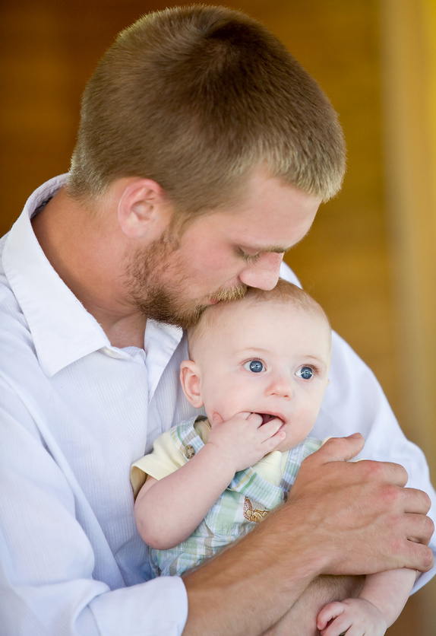
Defend your partner from others like you would defend yourself; at first your partner; your family; pride and honor. Defend your partner like yourself; be open to the desires of your partner.
For women: One captain, supplier and provider of shelter, endowed with different brains; biochemistry; skin; communication and thinking. God knows all that!
A Christian partner with same beliefs, (mutual attraction) same church bank (Grandfather’s advice). We are not from this world, we are in this world!!

With your kids:
- Be a role model for your kids, No Saucy clothing, spent quality time with your partner/family e.g. playing games, reading in front of the family (to read to your family), evening discussion, playing music, sports etc. Not so much TV, show your daughter and son what you can, teach them: changing a tire, baking, cooking, fixing… build with them a “hut” tree house, soapbox, write a letter at the beginning of the year with aims for the coming year. Thanks giving for the past year and Diary with the best moments of the family, the kids, partner etc.
- At the dinner you can exchange the most important things of the day, asking questions, share for e.g. the most interesting moment of the day, or what was the most interesting thing what we learned today or experienced with God
- Family traditions: meals together, pray with your kids, information book at the telephone desk: I am gone.., I love you; what a beautiful day and this happened today; etc.
- Christmas advent calendar (focus on family calendar),
- Good night story, listen to radio stories, playing games on long tours, word games: knowledge games, sing songs together etc. special Saturday breakfast, going shopping together, garage sale, special things for each child/ person (the child can choose how they want to spent a day only with daddy or mummy), …
- Family topic/slogan, reading night, construct your own bicycle and build it, teach them driving your car, change a tire etc., play together in hospitals, retirement homes (at Christmas), house music evenings (playing instruments, singing), movie night once a week (newest movie, less is more) or a bowling day once a week, etc.
- A family chronicle. Surprise your partner with a secret weekend tour…
- bake with your kids, build a soapbox, paper chase in a forest at Easter playing, spent quality time with each other, every child is unique, spent special time with your child (alone)
Prayer ritual e.g. lunch or quite time at the family breakfast
Deuteronomy 11:18-19 :"Fix these words of mine in your hearts and minds; tie them as symbols on your hands and bind them on your foreheads. Teach them to your children, talking about them when you sit at home and when you walk along the road, when you lie down and when you get up."

My favorite poem:
How rich are you?

True wealth is measured,
Not by how much you have,
But by how much you have
Of what you desire.

You can be the richest man
In the world
And still accounted poor,
If what you have is so little
Compared to what you desire.
And you can be truly rich
With very little,
If the little that you have
Is more than you desire.
- H. L. Neri -

Space for your thoughts:___________________________________________________________________________________________________________________________________________________________________________________________________________________________________________________________________________________________________________________________________________________________________________________________________________________________________________________________________________________________________________________________________________________________________________________________________________________________________________________________________________________________________________________________________________________________________________________________________________________________________________________________________________________________________________________________________________________________________________________________________________________________________________________________________________________________________________________________________________________________________________________________________________________________________________
:________________________________________________________________________________________________________________________________________________________________________________________________________________________________________________________________________________________________________________________________________________________________________________________________________________________________________________________________________________________________________________________________________________________________________________________________________________________________________________________________________________________________________________________________________________________________________________________________________________________________________________________________________________________________________________________________________________________________________________________________________________________________________________________________________________________________________________________________________________________________________________________________________________________________________

