USP

Unique selling propositions:

Pilot school for a worldwide school network, with a focus on the developing countries!!!
From Germany to Africa and beyond that!

Christian Institutions can use the concept and all that you need to start
a school. (Webpage links, materials etc.)

Idea behind the Concept

Network
The main aim of the ICS-Network idea is to support churches, Christian institutions in founding Christian schools, which offers a high quality education especially to 3rd world countries, to transmit the societies through well educated new leaders and to show God’s love to the students and teach them the knowledge of God’s word.

The ICS concept is also based on the idea to share experiences, materials and resources, as well as contacts with other member schools. It is a network that works where it is good, independent and necessary.

At the ICS Network Webpage it is possible for the Member schools to find fundraising partners (like: http://www.betterplace.org/en) for their schools, and conversely they can download materials from the Network of the ICS. The member schools send their materials to the ICS, ICS will load it up on the ICS Webpage. With a password every member school can use the resources.

Ideas and perceptions of the schools will be evaluated through the ICS and after positive evaluation the ICS absorbs it into the concept.

Another resource of the Webpage is the area of the Teacher Exchange program. Foreign teachers can find Member schools to support them in their work. The Schools can advertise the available teacher positions on the webpage.

The IFES (International Federation of Evangelical students), the Eureca (European Christian school network), IVCG(Christian Business Organization), partner schools like Meisoc (Mennonite Education Institution) and other Organizations will have a link on the Page.

Besides that, university students can support the schools with their skills. Required tasks are also on the webpage. The students can write their Master thesis or work in projects for the ICS-Schools etc.

ICS-Network platforms:
- ICS: Teachers without borders
- ICS Teacher and Student Exchange
- Senior Experts offer their help
- Ideas, materials and perceptions from ICS Schools
- Network Schools Tasks and Offer platform for University Students and Specialists
- Current issues and coming Events
- Internships in ICS Schools
- Therapists, Psychologists, other medical and pedagogical Specialists

Pedagogic concept

The pedagogic concept is almost obligatory (90 percent) for every ICS-Christian School Founding Member School.

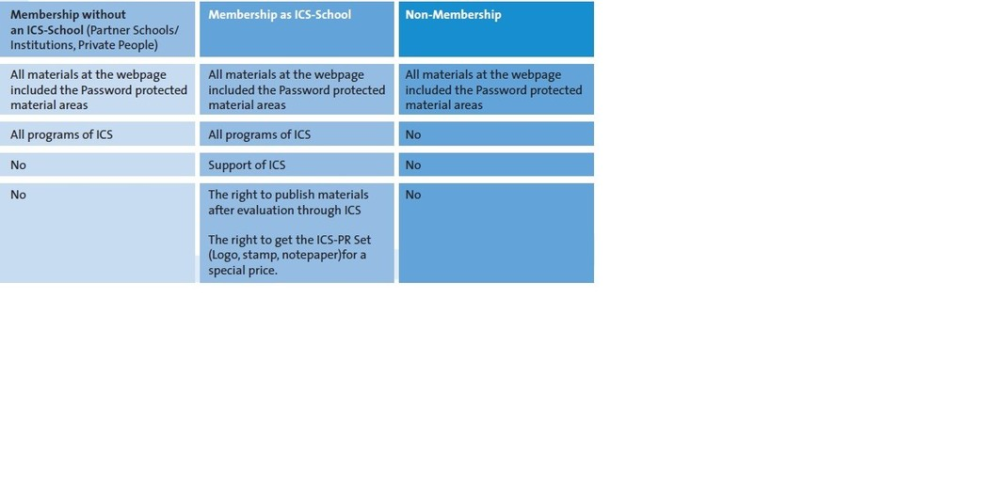

The school concept is worldwide unique in this set. The idea to settle a pilot school to distribute the concept worldwide is in the Christian world unique!
Only the International schools in Geneva have a comparative concept on an unchristian basis. That concept brings synergy effects like:

- The advantage of purchasing together saves a lot of money. using the same Logo, Design, Stamp, Notepaper
- The exchange of insights
- The exchange of materials
- The use of training opportunities (together)
…

Christian school: Faith statement of the Evangelical Alliance and the values of ICS
All staff accepts the statement and tries to be good Christian role models.

Family education centre has now as an aim or partly an offer; a room for
professions like Speech Therapists
The ICS school is asking Christian specialist in their district to support them for free, maybe once a week. A Therapist offers a consultation hour in the rooms of the school. In the long term this is to establish a family education centre. All at one place: School, Therapists, Specialists etc. less driving, closer cooperation…

Tutoring centre in Primary/Middle school
The students get special support where they are lacking during the school time. In the school entry level a teacher supports students one to one situation or in small groups of 6 students. In the Middle school, higher grade students or University students offer special tutoring lessons.

Entry level: Grade 0-2/flexible intake/good step over into school
From the age of 5 years it is possible to attend the school. The 5 year old students (Grade 0) spent each day 2 hours in a special class with social pedagogues (special preparation for grade one) and 2 hours in their future class, together with Grade one and two students. The step over is easier. Students at the age of 6 enter the school as is otherwise customary.

Township Internships/-work (ICS-Students are tutors or classroom assistants in the Townships), Scholarships for Township children! Top Education for 3rd world!!

Network of ICS-Schools (Advantage: acquire continued education, teacher and student exchange etc.)
See paragraph: idea behind the school.

Application oriented didactic
The sustainable use of knowledge and the answer to the question: “Wherefore?” contains the didactic principle. Ask yourself and the students “Wherefore”.

From grade 1-8 the students in these classes, will be with one class teacher (Finish system)

The pedagogic based on Pisa, Neuro science perceptions and international school proved concepts and the perceptions of Pestalozzi and Brophy
The perceptions of Prof. Spitzer about the importance of playful learning through playing games and a positive learning atmosphere (good character of teachers, personal interest in students and friendliness, clearness etc.) are important.

Year/Term abroad for everybody! (Partner schools like e.g. Meisoc/Canada)/
ICS-Student Exchange Program between ICS-Network Schools
The parents have to save 10 Euro each month (savings scheme) for their children. They transfer the money to a special school account. After the saving time, there will be enough money to cover all costs. The exchange includes the intake of the guest parent’s child of the partner school. The new insights will help the school and the student!

Security Concept of the School

Building/Playground: Oriented at the best
Noise reducing concept is oriented towards the architecture at international competition winners. The positive learning atmosphere of the school yard and the buildings are very important in our concept.

Entrepreneurs (Think Tank) Student activities
The school offers possibilities for students with ideas to implement them.

Life skill conference / Subject: Life skills
Some of the topics: Finances, Budget, Social Networks, Nutrition, Cooking, the first Flat, Law, Partnership, Family founding, Parenting, Education, Drugs, New Media, compulsive gambling etc. Traditional Values like: Etiquette guide and organizing a Ball.

Democratic School: School Parliament/Council: Right to a say!
Through the Council the students can decide together with the teachers about some school relevant topics.

Possible International School Cooperation with Partner Schools e.g. Meisoc/Canada
There will be partnerships with Schools outside of the ICS-Network.

International Christian Teacher Exchange Program
Teachers from Network schools and other schools change their working place for a few weeks! The new insights will help the school and the teachers!

“Teachers without borders” Program
Retired teachers/specialists e.g. Social worker, Speech therapists etc. support the Network schools with their knowledge and experiences.

Strong University student program (Internship, Cooperation and commission work)
Vision of a Win-Win Situation
High potential to save money, valid and in the Praxis used Work/Master Thesis, projects etc. cooperation with Christian Universities and IFES: International Fellowship of Evangelical Students and others.

Network Schools Tasks and Offer platform for University Students and Specialists Platform
ICS is convinced that worldwide there exists a huge potential for supporting school founding and existing schools through University Students. Every Student has the aim to produce something that is not only for the target of a grade, but helps others and is used in the praxis.

Therapists, Psychologists, other medical and pedagogical Specialists Program
The idea is orientated at the medical volunteers working in the USA. Especially in poor countries we do need this help! Specialists spent 3 hours per week in their ICS-School.

Senior Experts offer their help (Platform Specialists)
Former manager and specialists offer their support.

Day-long and week-long Internships, special working groups for ICS-Students
The school offers a variety of options to take a look into the work life.
Together with these Internships, the school offers Life skill Conference. At the Conference, the students learn a lot about the work life and their abilities (e.g. option for a personality test) and skills.

Learning contracts for students, beside degrees (Notes) (Swedish system)

Lessons warranty plus!
There is lessons warranty for parents and students. Beside the regular teachers the school also provides the school substitute teachers/students.

Evaluation concept: A learning institution
School, teachers and students get evaluated. The school improves itself on a continuing process based on the evaluation perceptions.

TAKE CARE OF TEACHERS; STUDENTS AND PARENTS
Good payment, support in teaching, year talks with the principal, a voice in the daily work, healthy working place etc. and the responsibility towards the students and parents need, they give an ear to them and encourage as well as support their needs.

Social activity duty for students
Each student has to attend a social activity group in school for e.g. retirement home group, tutoring group, hospital visitor group.

Duty subjects
Every student has to learn an instrument, attend the Bible/Philosophy/Religion subject, Life skill subject, First aid course, Entrepreneur weekend, Life skill conference and social group and the Tutoring/Internship Township program.

Media Concept: Whiteboards and Classmate-Tablet PCs: Old and new media competence

Obligatory ideas:
- German and PC is a possible didactic concept for schools with a high immigrant rate and big classes.
It is a German concept.
- Immersions classes: Information available from the International School Magdeburg/Germany!
- German exchange students club

Teaching God’s word and recommend a visit of a Bible school
Besides that’ it is also a matter close to ones heart to recommend that students visit a Bible school after the school time. To visit a Bible school after the school time offers a good opportunity to learn God’s word in a better, deeper way, to think about the future and to find a Christian partner. Especially the last point is very important, in our unchristian society it is very hard for the students to find a Christian partner in their home church, and you have to go to events. The Bible school time is a very good opportunity!

Christian families are the most important units in a society!!!

Further reasons for international schools/Network of ICS
http://www.youtube.com/watch?v=lZ9RnwnO0g8

